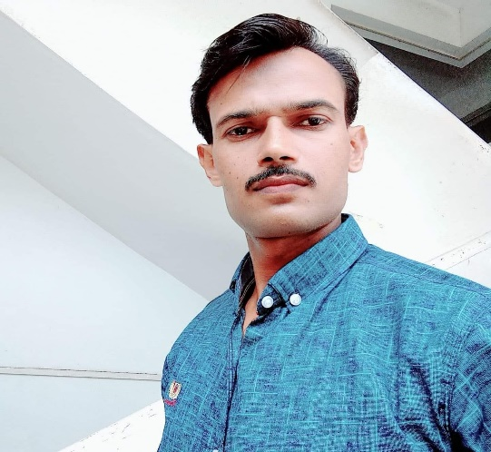

**SHAHAB UDDIN**

**S/o Sharafat Ali Khan**

**CAREER OBJECTIVE**

The aim is to work enthusiastically in a positive & creative manner to secure a challenging position which provides outstanding opportunities to utilize my current skills and would also help me to climb the ladder of success in a competitive world ahead.

WORK EXPERIENCE

* 06 Years’ Experience as a “Stitching Line Supervisor” in Eastern Garment (Pvt) Ltd.
* 08 Years’ Experience as a “Fido Sewing Machine Operator” in JB Export (Pvt) Ltd, NFK Export (Pvt) Ltd and Other Companies.

EDUCATION

Matriculation (Technical)

From Sindh Board of Technical Education.

PERSONAL INFORMATION

Date of Birth : 20-12-1986

CNIC No : 42401-382885-1

Domicile : Karachi (West)

Religion : Islam

LANGUAGE

* Urdu
* Panjabi
* English

SKILL

* Excellent Communication.
* Active Learning.
* Complex Problem Solving.

CONTACT

Cell# 0315-2030033

Address: House No. E-1490, Sector 10, Haryana Colony,

Orange Town, Karachi.